

The Very Hungry Caterpillar

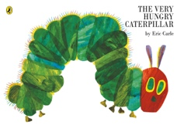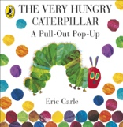 | Explore the storybook together
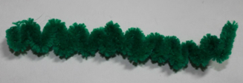 | Create a pipe-cleaner caterpillar (green body with red thread wrapped around one end), for your child to post through the holes in the pages
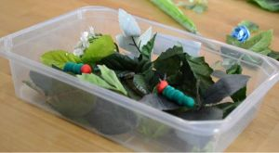 | If you have access to an outside area collect leaves with your child, or make paper leaves. Place them in a tray with caterpillars (finger puppets or simple models, pipe cleaners etc) inside for your child to find
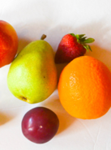 | Hide plastic fruits in shaving foam for your child to find
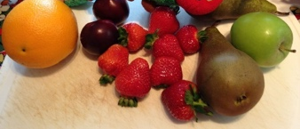  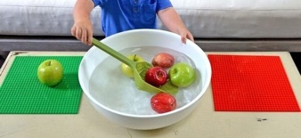  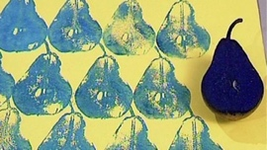 | Explore fruits, e.g. Apple, pears, plums, strawberries, oranges in a basket/bowl  - Look at, squeeze, smell, taste fruits  - Sorting different fruits (different fruits, by colour etc.)  - Use knife to cut fruits in half and explore them. Make a fruit salad for the family  - Use a blender to make a fruit smoothie  - Fruit printing
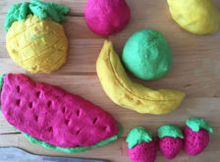 | Make playdough fruits etc. from the story (see handout on ‘Playdough activities’ for a recipe).  - Use the play food for sorting and matching  - Play shops- find the fruits and count them as they are put in a shopping bag  - Buy food using pretend money or a card  - Using a baking tin for buns, place 1 playdough apple in each section, then 2 playdough oranges, etc.  - Make fruit sequences using the playdough food (e.g. apple, orange, apple, orange, etc.)
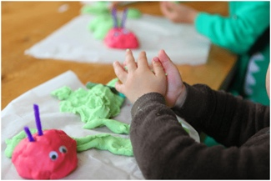 | Make a playdough caterpillar using red play dough, green playdough, goggly eyes and pipe cleaners, etc.
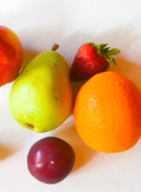 | Glitter shaving foam- hide plastic food items to find.  Can then sort- same/different, or count 1 or 2, etc.
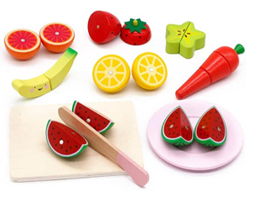 | Play food to cut up and match- same/different etc.
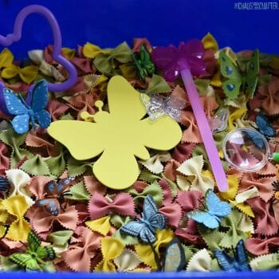 | Butterfly farfalle pasta (dyed/painted different colours- your child can be involved in making this in an earlier activity) in a tray.  Add paper cut-out butterflies in different colours.  Provide scoops and stirrers and containers (some with lids) for your child to explore
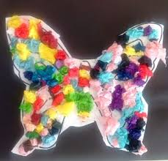 | Collages:  - Make a butterfly collage from different butterflies including:  Mark making with finger painting, chalks, colouring pens, etc.  Scrunching tissue paper to stick on outlines  outlines of illustrations elements  - Caterpillar collage- use different materials for each circle of the caterpillar
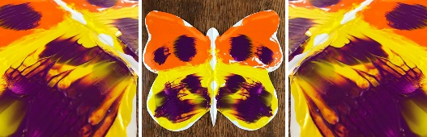 | Symmetry painting
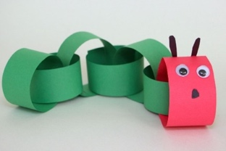 | Make a caterpillar paperchain
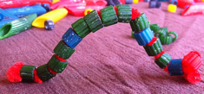 | Paint pasta tubes green and thread onto a string or pipe cleaner
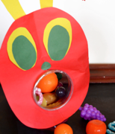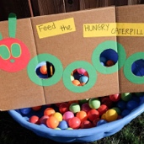 | Make a hungry caterpillar for your child to feed with plastic or playdough food
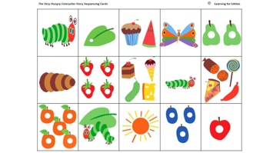 | Make a story sequence- cut out the pictures from the sequencing sheet at the end of this handout. Stick reach one onto a peg, and then peg them onto a line in the story sequence
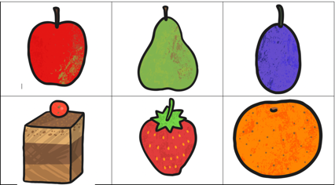 | Make a lotto game using the lotto sheets at the end of this handout

Sequencing cards

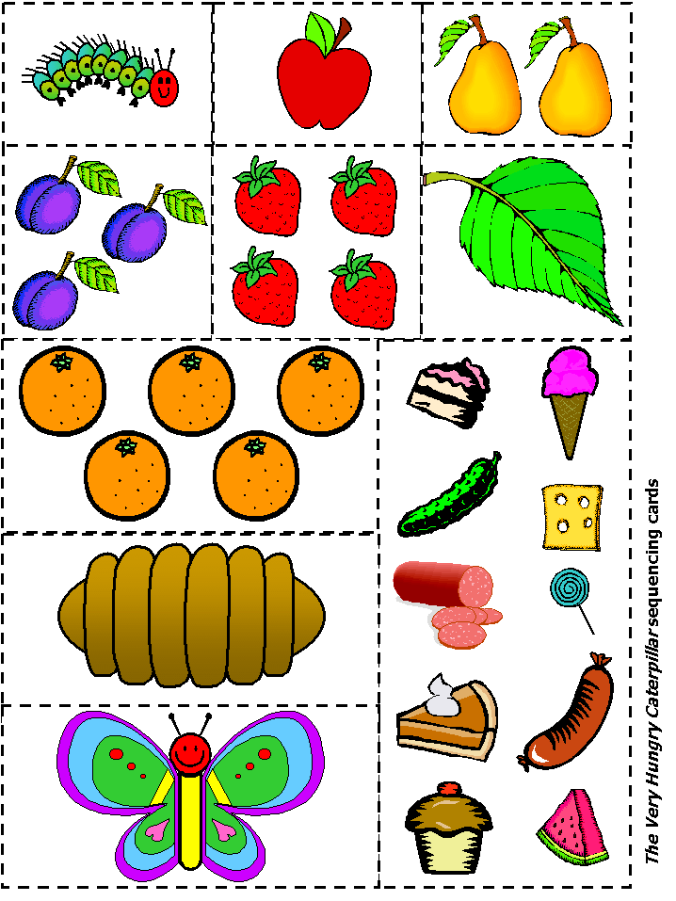

Lotto cards



