

Sensory play activities

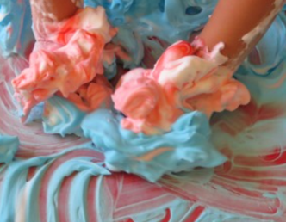 | Shaving foam or squirty cream on a large tray.  Add:  - Glitter  - Different food colouring or paint  - Cotton wool balls  - Rice
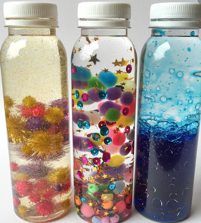 | Sensory bottles. Fill the bottle with water and add:  - A few drops of oil (mixed with food colouring)  - Glitter or sequins  - Small plastic shapes, beads, figures etc  GLUE THE LID ON SECURELY!
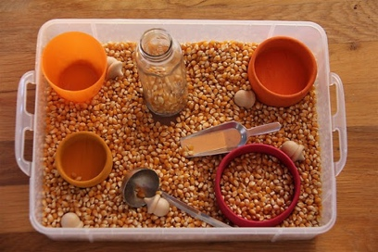 | Sensory boxes. Place dried materials in a box and bury objects in it.  Some suggestions are:  - Shredded paper  - Dried rice or pasta  - Wood shavings or chips  - Uncooked popcorn  Provide scoops, containers, funnels etc. to explore.
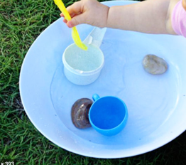 | Water play (this can be at bath-time). Use different objects such as:  - Containers to pour  - Things that float and sink  - Bubbles  - Sponges  - A doll to bath
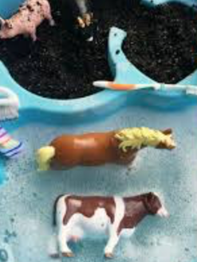 | ‘Old MacDonald had a farm’ with some dirty animals (in compost) that he needs to clean (provide an old toothbrush etc. to brush the animals with)
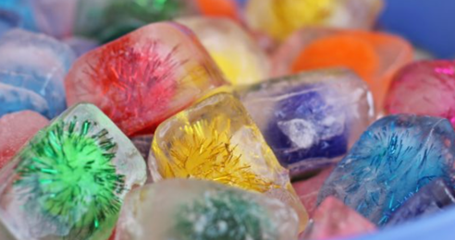 | Make up ice cubes with small objects in them, or freeze a small bag of water with objects in it.  Provide a bowl of warm water to melt the cubes in.
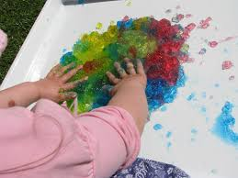  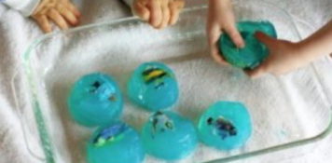 | Jelly play. Make up different coloured jellies.  Hide objects in when the jelly is made for your child to find.
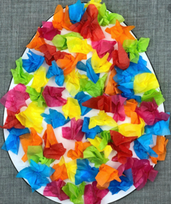 | Tear pieces of tissue paper or old magazines. Screw up into a ball and stick onto an outline drawing to make a collage
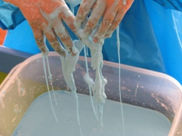  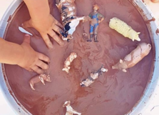 | Mix up cornflour with a small amount of water and food colouring to make a thick paste (this is very messy play!).  There are lots of variations, such as adding cocoa powder to make ‘mud’ for the farm animals, porridge oats, etc. to make different textures.
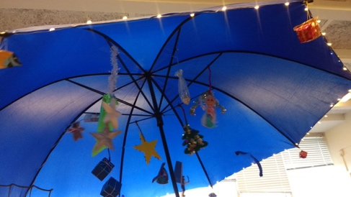 | Make a sensory umbrella (great for lying under to chill out).  Provide torches to shine onto the umbrella when lying underneath it.
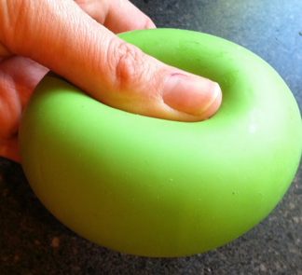 | Squeezy balloons (The Imagination Tree)  1 cup of cornflour  ½ cup hair conditioner  Balloons  Mix the cornflour and conditioner together. Break into small pieces and push inside inflated balloons. Tie securely
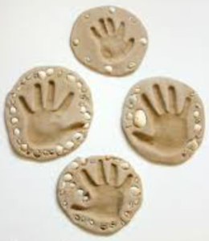 | Sand clay (The Imagination Tree)  2 cups clean sand  1½ cups plain flour  1¼ cups salt  1 cup warm water  Mix together sand, salt and flour.  Slowly add water and mix together, making sure it is not too sticky.  Knead dough on a floured surface until stretchy and soft (like playdough)  Use this to make prints, stick shells, beads etc. in to.
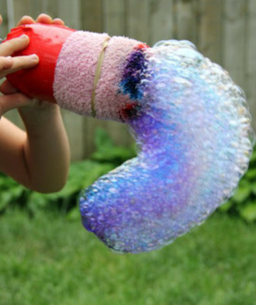 | Bubblesnakes  Old plastic bottle  Socks  Bubble mixture  Cut the bottom off a plastic bottle.  Pull a sock over the end, up to the top and use sticky tape to hold in place.  Dip sock-covered end into bubble mixture.  Blow through the top end.

